***Belly Breathing!***

Belly Breathing is a great way to relax your body, which can improve stress and pain.

**Reminders:**

* Slowly breathe in through your nose to the count of ___.
* Slowly breathe out through your mouth to the count of ___.
* Try to get your belly to move, *not* your chest

**Practice:**

* Aim for 20 minutes each day
* Rate how you felt afterwards from 1-10 (1=Tense, 10=Relaxed)
* You can practice laying down, sitting up, or standing up

**Practice Log:**

Date Time Time

Started Ended

_________ ________ ______

_________ ________ ______

_________ ________ ______

_________ ________ ______

_________ ________ ______

_________ ________ ______

_________ ________ ______

_________ ________ ______

_________ ________ ______

_________ ________ ______

_________ ________ ______

_________ ________ ______

**Resources:**

* **www.CopingClub.com**
  + By topic: Stress & Anxiety
  + Coping tools: Relaxation

video

* **Free Apps** 
  + *Breathe2Relax app*

Total Rating/Notes

Time

_________ ________________

_________ ________________

_________ ________________

_________ ________________

_________ ________________

_________ ________________

_________ ________________

_________ ________________

_________ ________________

_________ ________________

_________ ________________

_________ ________________

**For further information, please**

**contact:**

**_____________________________**

**_____________________________**

Belly Breathing!

 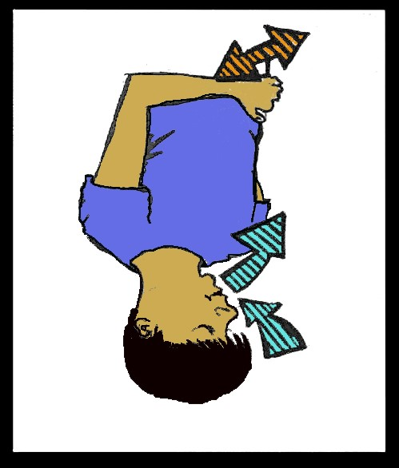

**Pediatric Consultation/Liaison Service**

**Norton Children’s Hospital**

Introduction to…